**Bug Report for Buggy Cars Rating Application**

Bug No 1:

Bug Title: Not able to use Back Navigation link

Steps to Reproduce:

1. Login to the <https://buggy.justtestit.org/> with valid credentials
2. Click on Popular Make block
3. Click on Buggy Rating which is top Left side one

Expected Result: User should go back to the main page of Application

Actual Result: User do not have option to go back to the main page from the Application because the link is broken.

Screenshots if any: 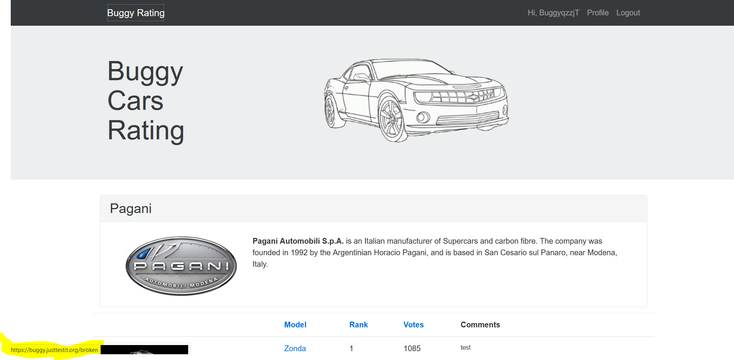

Priority: Medium

Environment: Test Environment

Bug No 2:

Bug Title: New Password spelling is incorrect in Profile page under Change Password section

Steps to Reproduce:

1. Login to the <https://buggy.justtestit.org/> with valid credentials
2. Click on Profile option

Expected Result: Under Change Password section, Field name should be ‘New Password’ not New ‘Pasword’

Actual Result: Under Change Password section, filed name is given as ‘New Pasword’ which is having spelling mistake.

Screenshots if any: 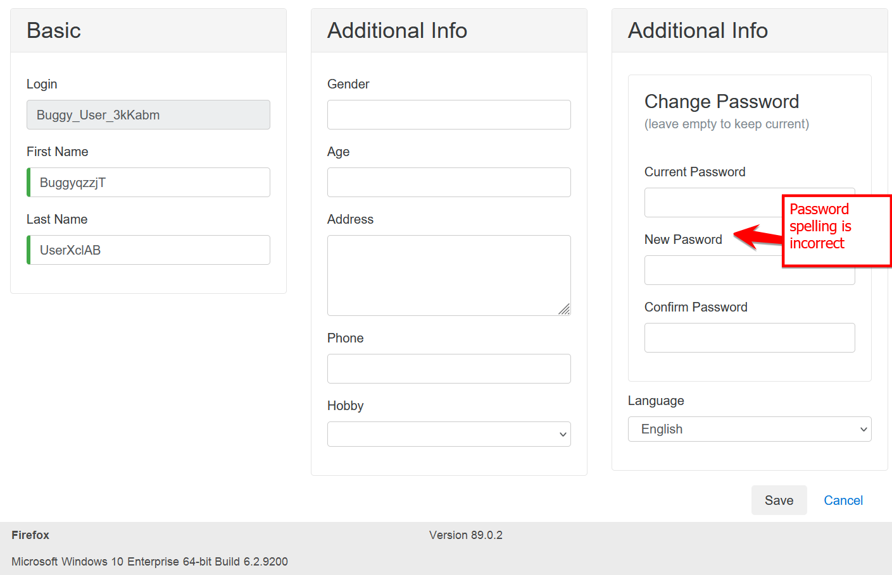

Priority: Medium

Environment: Test Environment

Bug No 3:

Bug Title: Author details are Blank in Popular Models page

Steps to Reproduce:

1. Login to the <https://buggy.justtestit.org/> with valid credentials
2. Click on Popular Make block
3. Click on any Mode hyper link from list.

Expected Result: Author details should display under Author Header to know who has given the comment.

Actual Result: Author details are blank under Author Header.

Screenshots if any: 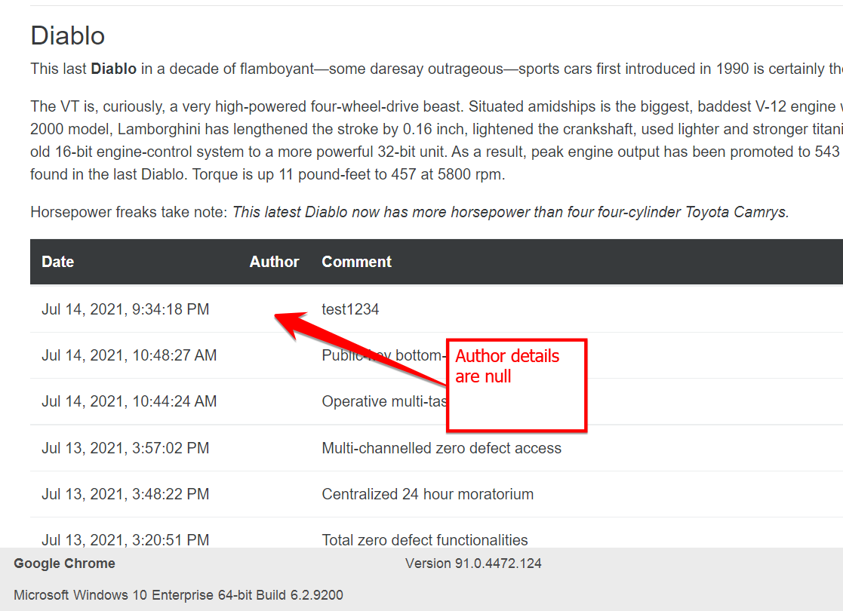

Priority: Medium

Environment: Test Environment

Bug No 4:

Bug Title: Rank numbers are not arranged correctly after Sorting (Rank 2 is showing in Page 3)

Steps to Reproduce:

1. Login to the <https://buggy.justtestit.org/> with valid credentials
2. Click on Overall Make block
3. Click on Rank hyper link to sort

Expected Result: Cars Rank numbers should be displayed in Ascending order

Actual Result: Cars Rank numbers is not showing in Ascending order (Rank 2 is showing in Page 3)

Screenshots if any: Before Clicking on Rank for Sorting:

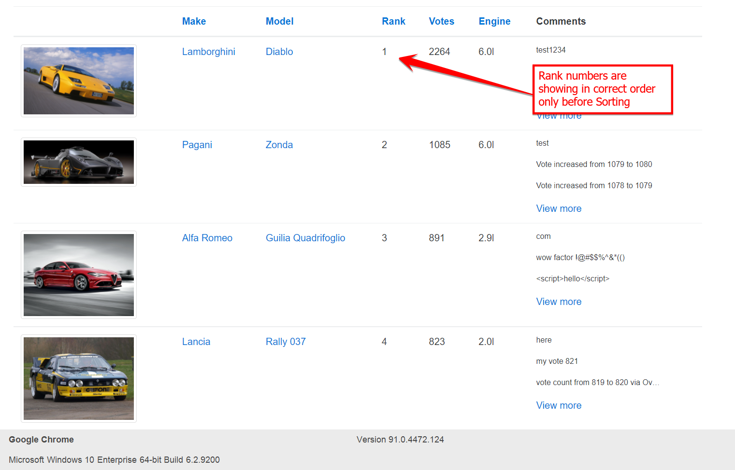

After clicking on Rank to sort:

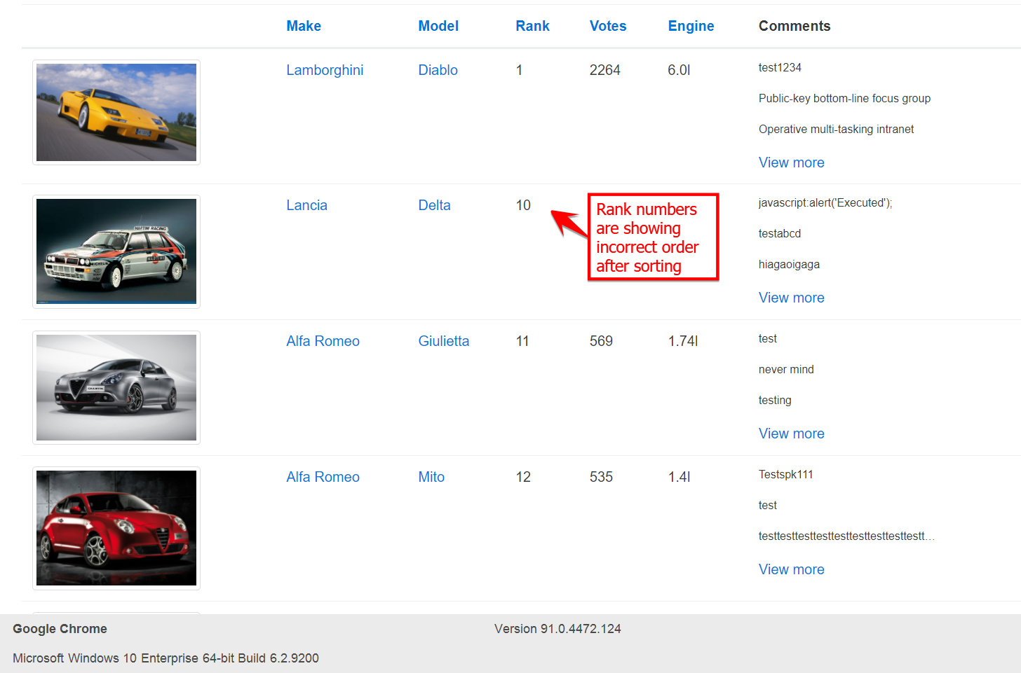

Priority: Medium

Environment: Test Environment

Bug No 5:

Bug Title: Car Image is not displaying for Lancia Ypsilon model under Overall Rating section

Steps to Reproduce:

1. Login to the <https://buggy.justtestit.org/> with valid credentials
2. Click on Overall Rating section
3. Check for the Car logos in all pages

Expected Result: For Lancia Ypsilon car also it should display car model picture As for all the others its showing a model car picture

Actual Result: For Lancia Ypsilon car there is no model picture. Instead of Picture its showing Car name in text format

Screenshots if any: 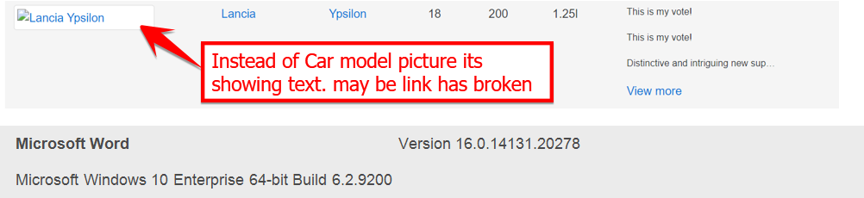

Priority: Medium

Environment: Test Environment

Bug No 6:

Bug Title: All Headers should have fixed length across all in the page

Steps to Reproduce:

1. Login to the <https://buggy.justtestit.org/> with valid credentials
2. Click on Overall Rating section from main Page
3. Click on View more hyper link of Lancia Ypsilon car text from list

Expected Result: Author and Comment Header length should be aligned to the same length. So when user enter long text it should wrap to the next line.

Actual Result: Author and Comment headers length is not same so Author column is taking more space in the page when its having long text.

Screenshots if any:

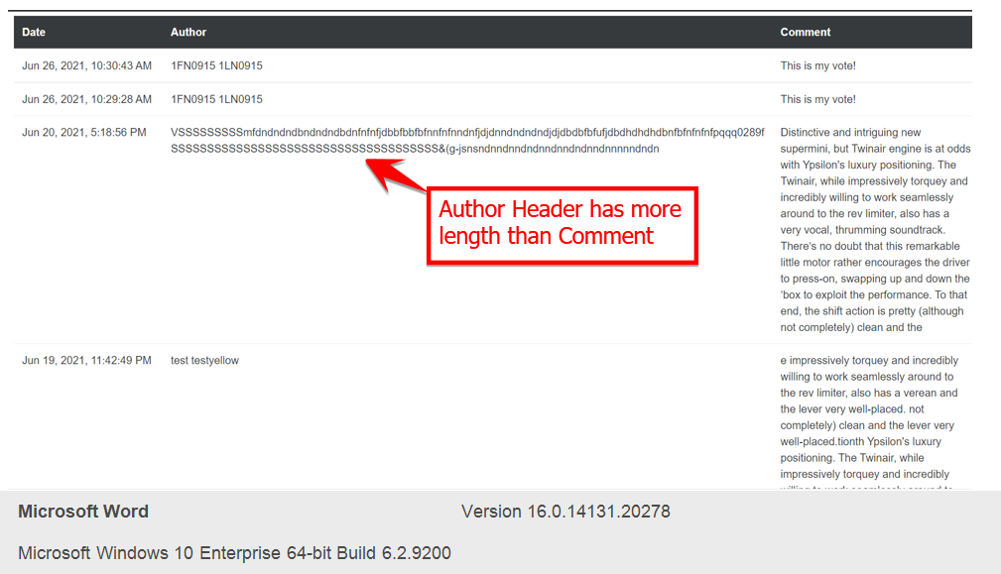

Priority: Low

Environment: Test Environment

Bug No 7:

Bug Title: Firefox browser Popular Model Page is showing as Loading but not loaded

Steps to Reproduce:

1. Login to the <https://buggy.justtestit.org/> with valid credentials using Firefox browser
2. Click on Popular Model section from main Page

Expected Result: Popular Model page details should be displayed.

Actual Result: In Firefox browser Page is showing as Loading but not loaded.

Screenshots if any:

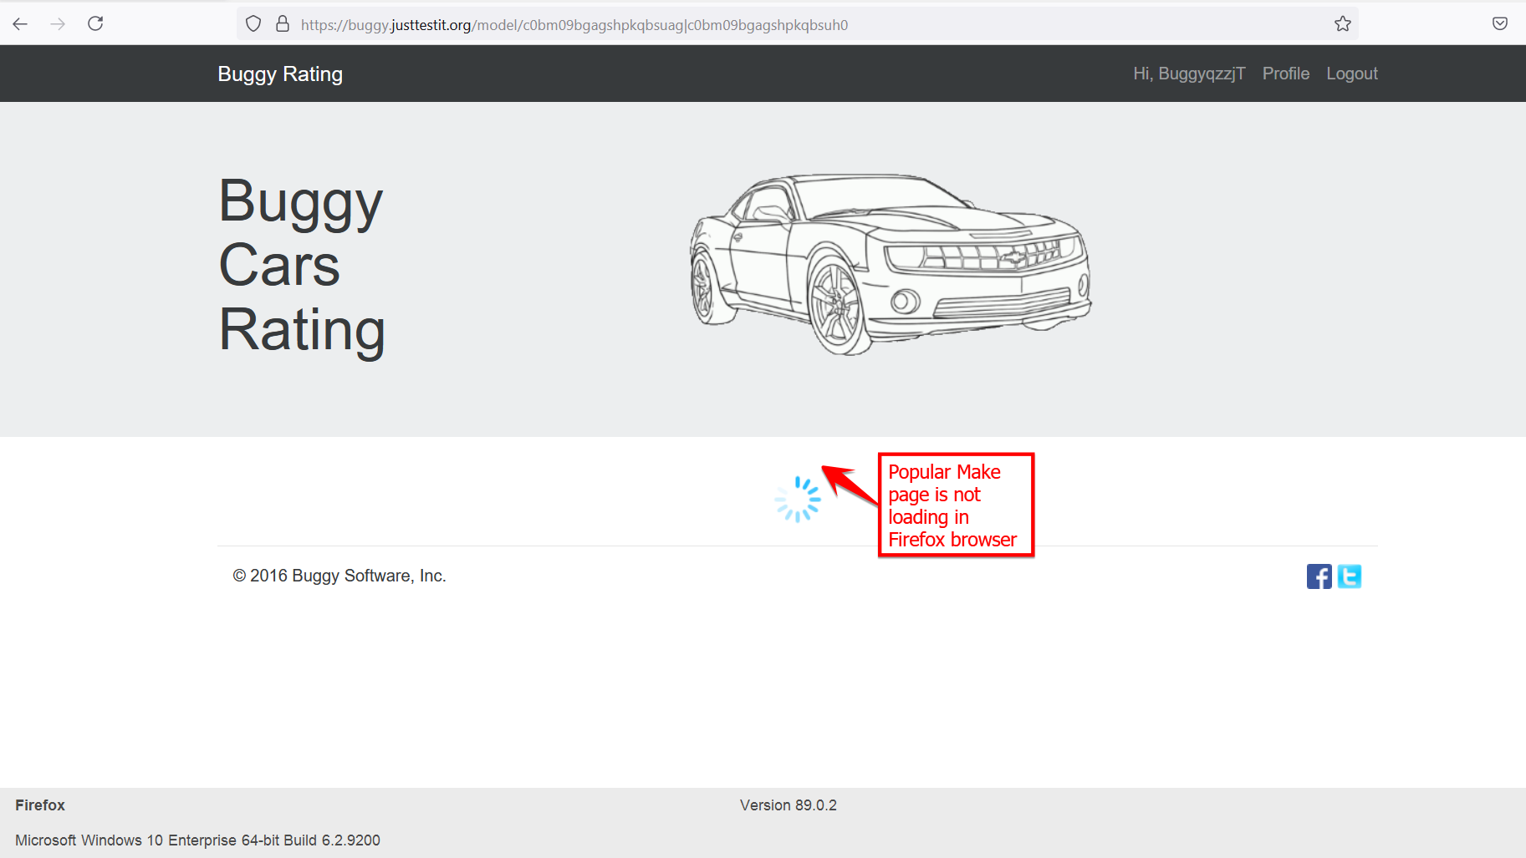

Priority: Low

Environment: Test Environment